Section 0-

1.

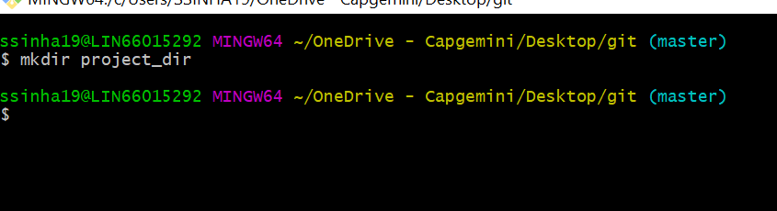

2.

3.

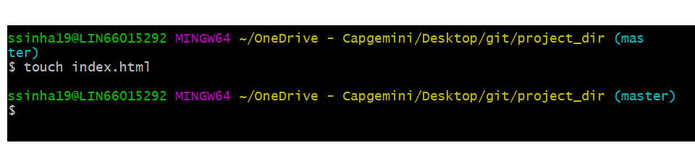

4.

5.

6.

7.

8.

9 & 10.

First type – >touch .gitignore ->go to local directory ->edit .gitignorefile -> type \*txt ->save it -> check status

11.

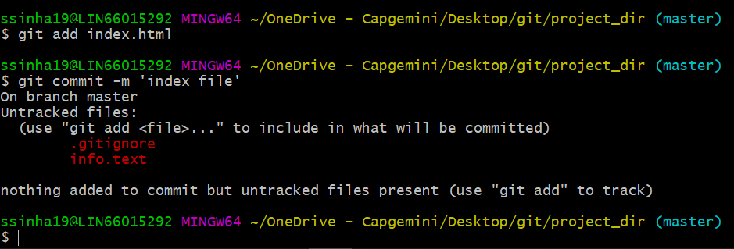

12.

13.

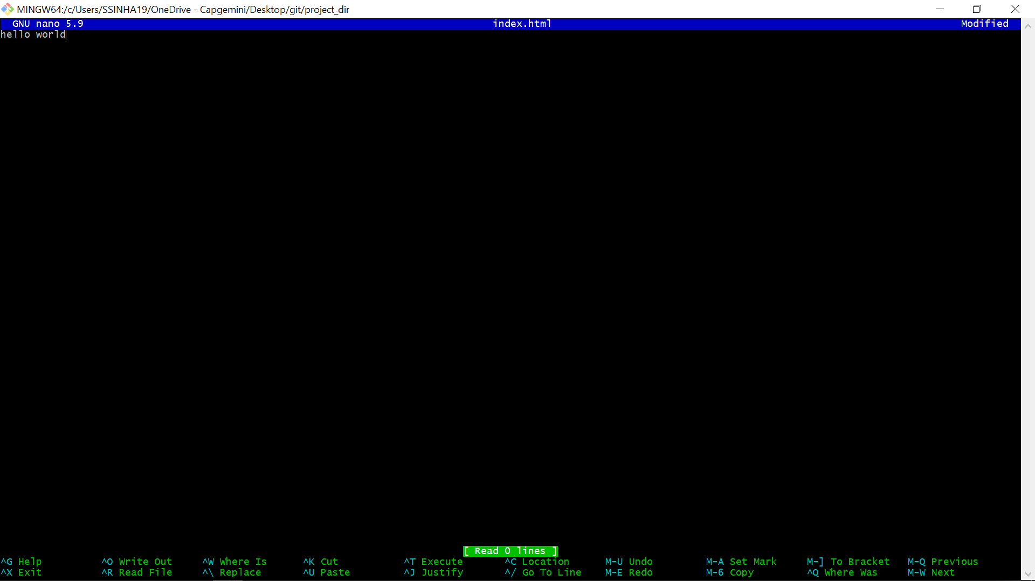

14.

15.



16.



17.

18.



19.

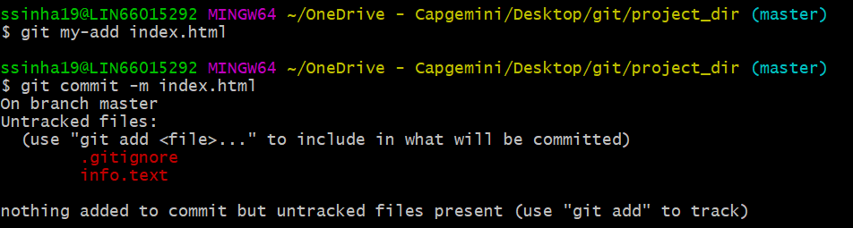

20.



SECTION 2

22.

23.





24.

25.



26.



27.



28.

29.

30.

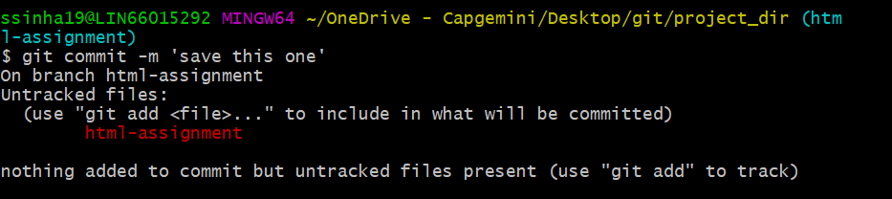

31. 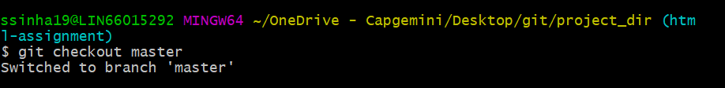

33.



35.

36.

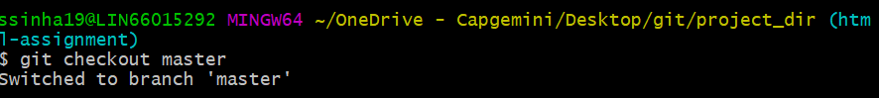

37.

38.

Section 2

1.



2.



3,4.

5.

6.

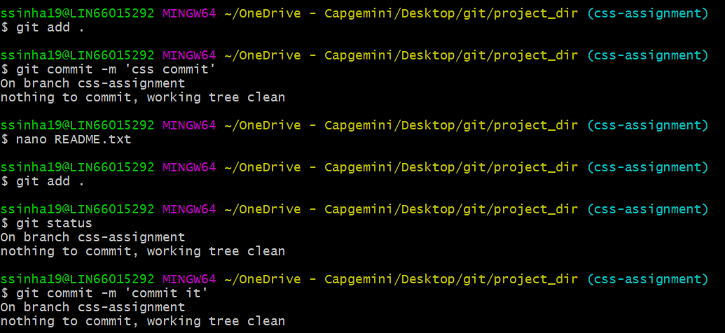

7.



8.

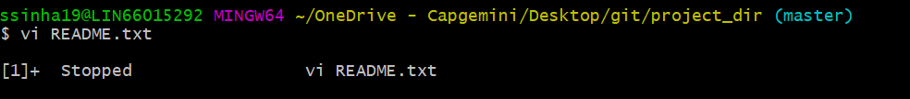

9.



10.

11.

12.



13.



14.



Section 3

1,2.

4.

5.

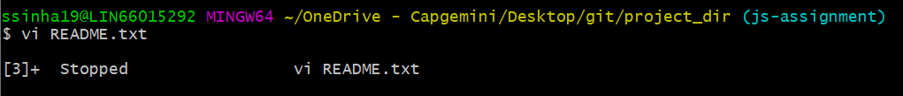

6.

7.



8.

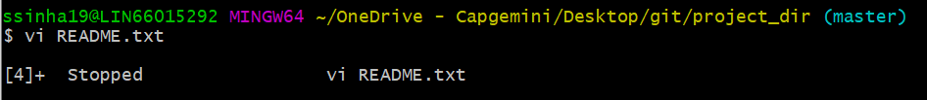

9.



10,11.

12.



13.

14.



GIT REMOTING

